BUSINESS NEWS PRESS RELEASE

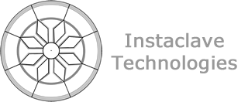

CONTACT INFORMATION:
Instaclave Technologies
Layla Lyne-Winkler
415-244-7898
llynewinkler@instaclave.com
RELEASE DATE:
January 3rd 2021

FOR IMMEDIATE RELEASE

Intaclave Technologies has fabricated the strongest Carbon Fiber Aerospace parts using its proprietary DPART Technology

DPART process parts for Space and Aerospace applications test to be 25-30% stronger than traditional fabrication methods

{San Francisco, California, Jan. 3 2021} – Instaclave Technologies has been in deep research with its DPART (Differential Pressure Assisted Resin Transfer) technology.

"As part of RFP for both the National Science Foundation (NSF) and the National Aeronautics and Space Administration (NASA), we have had exceptional results with our testing. Using our proprietary DPART fabrication methods, we have created aerospace parts that are 25-30% stronger than traditional aerospace manufacturing techniques. – January 6, 2020."

"We are very excited about the development of our DPART technologies", declared John Steven Calder, Instaclave Technologies Founder & CEO. " We see this as a milestone in the development of our multidisciplinary application of our CLS & DPART technologies.

